**QSMART – CG HEATER REPLACEMENT**

**PROCEDURE**

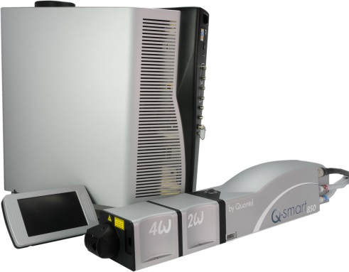

**Toolkit:**

Allen keys

**System**: QSMART

|  |  |
| --- | --- |
| **SM010360** | **Q-SMART CG HEATER ASSEMBLY** |

**Purpose**: This document details how to change the CG heater

|  |  |  |
| --- | --- | --- |
| Revision | date | modification |
| Initial issue | July 4, 2014 |  |
|  |  |  |
|  |  |  |
|  |  |  |

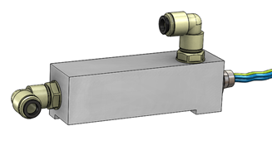

# DISASSEMBLY

* Open the ICE and the cooling group

*See procedure* *“CG - SM010355-COOLING GROUP ASSEMBLY* “

* Remove the 2 screws at the back of the chassis to unfasten the heater
* Remove the 2 tubes

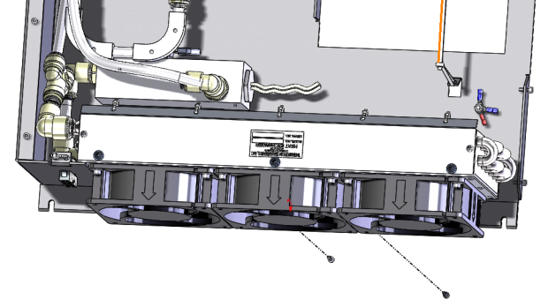

3- Remove the tube of the exchanger in the lower connection of the heater

1- Remove the 2 screws (BHC M3x10) at the back of the chassis to unfasten the heater

2- Remove the tube

# IMPLEMENTATION

|  |  |  |
| --- | --- | --- |
| 2.00 | V/BHC-M0310A4 | BHC M3-10 INOX A4 |



1- Fit the exchanger tube in the lower connection of the heater

3- Attach the heater with two BHC M3x10 screws from the back side of the chassis

2- Saisissez du texte, l'adresse d'un site Web ou [importez un document à traduire.](https://translate.google.com/?tr=f&hl=fr)

Essayez avec cette orthographe : [Fixer le bidon avec un ***Tirap*** Métallique comme sur le dessin](javascript:void(0))

Fit the return tube in the upper head connection of the heater.

# TEST AND CLOSING

* Perform the test of CG and close.
* Close the ICE

*Refer to "CG-Test & closing" and "CG - SM010355-COOLING GROUP ASSEMBLY"*